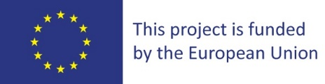
Kukes, 04 April 2022

Notice on selection according to points earned

Gjakova and Kukes Clean Water Project

Contracting authority
Kukes Municipality
Our ref #.: CWP/KS/006

SUBJECT: INVITATION TO TENDER FOR Construction Works
Lot Nr. 1: Construction works
Construction of the Collector in Kukës
Kukës /Kukes
Location – Albania*

Dear Mr/Ms,Kujdesi Todaj

After evaluation by the evaluation commite, you have arrived this score:

REF: CWP/KS/006
 | Eliminated
 | Bidder 1 Name 1 Drin -1 | Bidder 2 Name Ndregjoni Sh. p.k | Bidder 3 Name Denolt Shpk | Bidder 4 Name
Technical score * 0,80 | Eliminated | 70.19 | 80.00 | Eliminated
Financial score * 0,20 |  | 19.94 | 20.06 | 0.00
Overall score | 0.00 | 90.14 | 100.06 | 0.00
Final ranking | 3 | 2 | 1 | 0
Two companies have scored equally on overall score. Based on technical score result bidder one is recommended as the first choice to start negotiations with.

KRYETARI
Safet GJICI
NE MUNGESE DHE ME POROSI
ZV/KRYETARI
Granit GJANA

